**How to Create an EBS Volume from a Snapshot**

Amazon Elastic Block Store (Amazon EBS) offers persistent storage for the Amazon EC2 instances through the EBS volumes. Snapshots can be used to create new Amazon EBS volumes, which will have all the available data snapped during the point-in snapshots.

This demonstrates how to create a volume from a snapshot:

1. Go to the AWS console through the URL [http://aws.amazon.com/console.](http://aws.amazon.com/console) Select the EC2 service. From the EC2 dashboard, select EBS Snapshots or Snapshots.

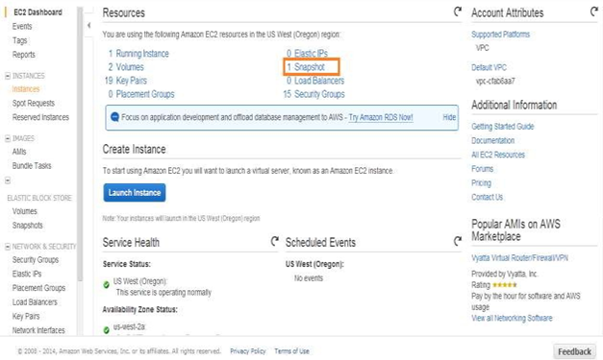

1. The snapshot dashboard lists all the snapshots owned by the user in that region. Select a snapshot from which the user wants to create the volume. Click on the “Create Volume” button from Action Tab

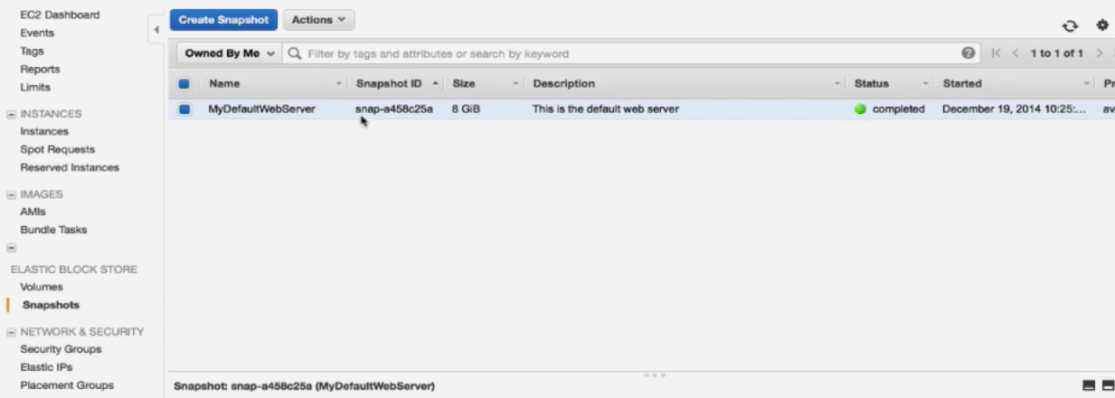

1. Select the volume type, size of the volume, IOPS (if volume type is Provisioned IO), and the availability zone. The snapshot ID will automatically be selected based on the snapshot selected in step#2.

Click on the “Yes, Create” button.

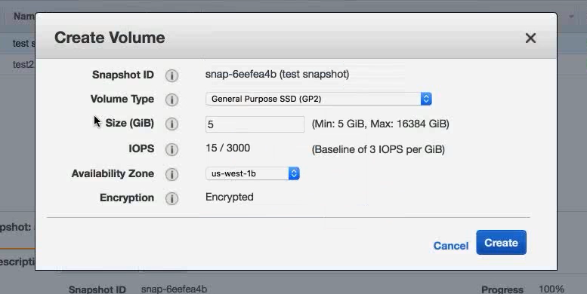

1. The new volume from the snapshot will be created and be in an available state as it is not attached to any instance.

